

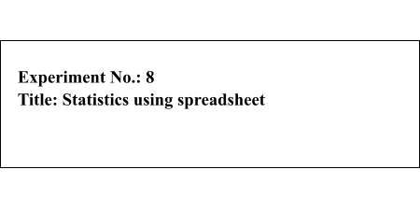



|  |  |  |
| --- | --- | --- |
| **Batch: A3** | **Roll No.:16010421119** | **Experiment No.: 8** |

**Aim: 1.**To generate random numbers and draw samples from the data set using MS Excel

**2.** Hypothesis testing for

mean **Resources needed:** MS Excel

**Theory**

**Problem Statement:**   
Generate random numbers using rand() / randbetween() / Data Analysis Toolpack and draw simple random samples from the dataset.

**Concepts**

**Sample and Sampling**

A Sample is a part of the total population. It can be an individual element or a group of elements selected from the population. Although it is a subset, it is representative of the population and suitable for research in terms of cost, convenience, andtime.

A good sample is one which satisfies all or few of the following conditions:

Representativeness: Good samples are those who accurately represent the population. On measurement terms, the sample must be valid. The validity of a sample depends upon its accuracy.

Accuracy: An accurate (unbiased) sample is one which exactly represents the population. It is free from any influence that causes any differences between sample value and population value.

Size: The sample size should be such that the inferences drawn from the sample are accurate to a given level of confidence to represent the entire population under study.

Sampling is the act, process, or technique of selecting a representative part of a population for the purpose of determining the characteristics of the whole population. Sampling is that part of statistical practice concerned with the selection of an unbiased or random subset of individual observations within a population of individuals intended to yield some knowledge about the population of concern, especially for the purposes of making predictions based on statistical inference. Sampling is an important aspect of data collection.

Population OR Universe: The entire aggregation of items from which samples can be drawn is known as a population. Population, contrary to its general notion as a nation’s entire population has a much broader meaning in sampling. “N” represents the size of the population.

An operational sampling process can be divided into seven steps as given below:

|  |  |
| --- | --- |
| 1.  2.  3.  4.  5. | Defining the target population.  Specifying the sampling frame.  Specifying the sampling unit.  Selection of the sampling method.  Determination of sample size. |



6. Specifying the sampling plan.

7. Selecting the sample.

There are two basic approaches to sampling:

1. Probabilistic Sampling

2. Non-probabilistic sampling.

A Probabilistic sampling scheme is one in which every unit in the population has a chance (greater than zero) of being selected in the sample, and this probability can be accurately determined.

Types of Probabilistic Sampling

●Simple random sampling

●Systematic sampling

●Stratified sampling

●Multistage cluster sampling

Non-probabilistic Sampling It involves the selection of units based on factors other than random chance. It is also known as deliberate sampling and purposive sampling.

Types of Non-Probabilistic Sampling

|  |  |
| --- | --- |
| ● ● ● ● | Convenience sampling  Quota sampling  Judgment sampling  Snowball sampling |

[**Simple Random Sampling:**](https://www.mbaknol.com/research-methodology/simple-random-sampling-in-research/)

A sampling process where each element in the target population has an equal chance or probability of inclusion in the sample is known as Simple Random Sampling. For ex, if a sample of 15000 names is to be drawn from the telephone directory, then there is equal chance for each number in the directory to be selected. These numbers (serial no of name) could be randomly generated by the computer or picked out of a box. These numbers could be later matched with the corresponding names thus fulfilling the list. In small populations random sampling is done without replacement to avoid the instance of a unit being sampled more thanonce.

**Hypothesis Testing for mean:**

hypothesis test of a mean can be conducted, when the following conditions are met:

▪ The sampling method is [simple random sampling.](https://stattrek.com/Help/Glossary.aspx?Target=Simple%20random%20sampling)



▪ The sampling distribution is normal or nearly normal.

▪ Generally, the sampling distribution will be approximately normally distributed if any of

the following conditions apply.

▪ The population distribution is normal.

▪ The population distribution is [symmetric,](https://stattrek.com/Help/Glossary.aspx?Target=Symmetry) [unimodal,](https://stattrek.com/Help/Glossary.aspx?Target=Unimodal%20distribution) without [outliers,](https://stattrek.com/Help/Glossary.aspx?Target=Outlier) and the sample

size is 15 or less.

▪ The population distribution is moderately [skewed,](https://stattrek.com/Help/Glossary.aspx?Target=Skewness) unimodal, without outliers,

and the sample size is between 16 and 40.

▪ The sample size is greater than 40, without outliers.

This approach consists of four steps: (1) state the hypotheses, (2) formulate an analysis plan,

(3) analyze sample data, and (4) interpret results.

**State the Hypotheses**

Every hypothesis test requires the analyst to state a [null hypothesis](https://stattrek.com/Help/Glossary.aspx?Target=Null%20hypothesis) and an [alternative](https://stattrek.com/Help/Glossary.aspx?Target=Alternative%20hypothesis)

[hypothesis.](https://stattrek.com/Help/Glossary.aspx?Target=Alternative%20hypothesis) The hypotheses are stated in such a way that they are mutually exclusive. That

is, if one is true, the other must be false; and vice versa.

The table below shows three sets of hypotheses. Each makes a statement about how the

population mean μ is related to a specified value M. (In the table, the symbol ≠means " not

equal to ".)

|  |  |  |  |  |  |  |  |  |  |  |  |  |  |  |  |  |  |  |
| --- | --- | --- | --- | --- | --- | --- | --- | --- | --- | --- | --- | --- | --- | --- | --- | --- | --- | --- |
| |  |  |  |  |  |  | | --- | --- | --- | --- | --- | --- | | Set | Null hypothesis | |  | | --- | | Alternative hypothesis | | |  | | --- | | Number of tails | | | 1 | μ = M | μ ≠M | 2 | | 2 | μ >= M | μ < M | 1 | | 3 | μ ≤M | μ > M | 1 | |

The first set of hypotheses (Set 1) is an example of a [two-tailed test,](https://stattrek.com/Help/Glossary.aspx?Target=Two_tailed_test) since an extreme value

on either side of the [sampling distribution](https://stattrek.com/Help/Glossary.aspx?Target=Sampling_distribution) would cause a researcher to reject the null

hypothesis. The other two sets of hypotheses (Sets 2 and 3) are [one-tailed tests](https://stattrek.com/Help/Glossary.aspx?Target=One_tailed_test), since an

extreme value on only one side of the sampling distribution would cause a researcher to

reject the null hypothesis.

**Formulate an Analysis Plan**

The analysis plan describes how to use sample data to accept or reject the null hypothesis. It

should specify the following elements.

▪ Significance level. Often, researchers choose [significance levels](https://stattrek.com/Help/Glossary.aspx?Target=Significance%20level) equal to 0.01,

0.05, or 0.10; but any value between 0 and 1 can be used.



▪ Test method. Use the [one-sample t-test](https://stattrek.com/Help/Glossary.aspx?Target=One-sample%20t-test) to determine whether the hypothesized mean

differs significantly from the observed sample mean.

**Analyze Sample Data**   
**]**Using sample data, conduct a one-sample t-test. This involves finding the standard error, degrees of freedom, test statistic, and the P-value associated with the test statistic.

▪ Standard error. Compute the [standard error](https://stattrek.com/Help/Glossary.aspx?Target=standard%20error) (SE) of the samplingdistribution.

SE = s * sqrt{ ( 1/n ) * [ ( N - n ) / ( N - 1 ) ] }

where s is the standard deviation of the sample, N is the population size, and n is the sample size. When the population size is much larger (at least 20 times larger) than the sample size, the standard error can be approximated by:

SE = s / sqrt( n )

▪ Degrees of freedom. The degrees of freedom (DF) is equal to the sample size (n)

minus one. Thus, DF = n - 1.

▪ Test statistic. The test statistic is a t statistic (t) defined by the following equation.

t = (x - μ) / SE

where x is the sample mean, μ is the hypothesized population mean in the nu**l** hypothesis, and SE is the standard error.

▪ P-value. The P-value is the probability of observing a sample statistic as extreme as

the test statistic. Since the test statistic is a t statistic, use the [t Distribution](https://stattrek.com/Tables/T.aspx)   
[Calculator](https://stattrek.com/Tables/T.aspx) to assess the probability associated with the t statistic, given the degrees of freedom computedabove.

**Interpret Results**

If the sample findings are unlikely, given the null hypothesis, the researcher rejects the null hypothesis. Typically, this involves comparing the P-value to the [significance level,](https://stattrek.com/Help/Glossary.aspx?Target=Significance%20level) and rejecting the null hypothesis when the P-value is less than the significance level.

**Test Your Understanding**

Two sample problems illustrate how to conduct a hypothesis test of a mean score. The first problem involves a two-tailed test; the second problem, a one-tailed test.

**Problem 1: Two-Tailed Test**

An inventor has developed a new, energy-efficient lawn mower engine. He claims that the



engine will run continuously for 5 hours (300 minutes) on a single gallon of regular gasoline. From his stock of 2000 engines, the inventor selects a simple random sample of 50 engines for testing. The engines run for an average of 295 minutes, with a standard   
deviation of 20 minutes. Test the null hypothesis that the mean run time is 300 minutes against the alternative hypothesis that the mean run time is not 300 minutes. Use a 0.05 level of significance. (Assume that run times for the population of engines are normally distributed.)   
Solution: The solution to this problem takes four steps: (1) state the hypotheses, (2) formulate an analysis plan, (3) analyze sample data, and (4) interpret results. We work through those steps below:

▪ State the hypotheses. The first step is to state the null hypothesis and an

alternative hypothesis.   
 Nu**l** hypothesis: μ = 300

Alternative hypothesis: μ ≠300

Note that these hypotheses constitute a two-tailed test. The null hypothesis will be rejected if the sample mean is too big or if it is too small.

▪ Formulate an analysis plan. For this analysis, the significance level is 0.05. The test

method is a [one-sample t-test.](https://stattrek.com/Help/Glossary.aspx?Target=One-sample%20t-test)

▪ Analyze sample data. Using sample data, we compute the standard error (SE),

degrees of freedom (DF), and the t statistic test statistic (t).

SE = s / sqrt(n) = 20 / sqrt(50) = 20/7.07 =

2.83 DF = n - 1 = 50 - 1 = 49

t = (x - μ) / SE = (295 - 300)/2.83 = -1.77

where s is the standard deviation of the sample, x is the sample mean, μ is the hypothesized population mean, and n is the sample size.

Since we have a [two-tailed test,](https://stattrek.com/Help/Glossary.aspx?Target=Two-tailed%20test) the P-value is the probability that the t statistic having 49 degrees of freedom is less than -1.77 or greater than 1.77.

We use the [t Distribution Calculator](https://stattrek.com/Tables/t.aspx) to find P(t < -1.77) = 0.04, and P(t > 1.77) = 0.04. Thus, the P-value = 0.04 + 0.04 = 0.08.

▪ Interpret results. Since the P-value (0.08) is greater than the significance level

(0.05), we cannot reject the null hypothesis.

Note: If you use this approach on an exam, you may also want to mention why this approach is appropriate. Specifically, the approach is appropriate because the sampling method was simple



random sampling, the population was normally distributed, and the sample size was small relative to the population size (less than 5%).

**Problem 2: One-Tailed Test**

Bon Air Elementary School has 1000 students. The principal of the school thinks that the average IQ of students at Bon Air is at least 110. To prove her point, she administers an IQ test to 20 randomly selected students. Among the sampled students, the average IQ is 108 with a standard deviation of 10. Based on these results, should the principal accept or reject her original   
hypothesis? Assume a significance level of 0.01. (Assume that test scores in the population of engines are normally distributed.)

Solution: The solution to this problem takes four steps: (1) state the hypotheses, (2) formulate an analysis plan, (3) analyze sample data, and (4) interpret results. We work through those steps below:

▪ State the hypotheses. The first step is to state the null hypothesis and an

alternative hypothesis.

Nu**l** hypothesis: μ >= 110

Alternative hypothesis: μ < 110

Note that these hypotheses constitute a one-tailed test. The null hypothesis will be rejected if the sample mean is too small.

▪ Formulate an analysis plan. For this analysis, the significance level is 0.01. The test

method is a [one-sample t-test.](https://stattrek.com/Help/Glossary.aspx?Target=One-sample%20t-test)

▪ Analyze sample data. Using sample data, we compute the standard error (SE),

degrees of freedom (DF), and the t statistic test statistic (t).

SE = s / sqrt(n) = 10 / sqrt(20) = 10/4.472 =

2.236 DF = n - 1 = 20 - 1 = 19

t = (x - μ) / SE = (108 - 110)/2.236 =  
-0.894

where s is the standard deviation of the sample, x is the sample mean, μ is the hypothesized population mean, and n is the sample size.

Here is the logic of the analysis: Given the alternative hypothesis (μ < 110), we want to know whether the observed sample mean is small enough to cause us to reject the null hypothesis.

The observed sample mean produced a t statistic test statistic of -0.894. We use the [t](https://stattrek.com/Tables/t.aspx)



[Distribution Calculator](https://stattrek.com/Tables/t.aspx) to find P(t < -0.894) = 0.19. This means we would expect to find a sample mean of 108 or smaller in 19 percent of our samples, if the true population IQ were   
110. Thus the P-value in this analysis is 0.19.

▪ Interpret results.

▪ Since the P-value (0.19) is greater than the significance level (0.01), we cannot

reject the null hypothesis.

Note: If you use this approach on an exam, you may also want to mention why this approach is appropriate. Specifically, the approach is appropriate because the sampling method was simple random sampling, the population was normally distributed, and the sample size was small relative to the population size (less than5%)

**Procedure:**  
**•** Draw random numbers in MS Excel using Rand() / Rand between() and   
using Data Analysis Tool pack draw N(100, 15) random numbers  
• Generate 4 (2 each) sample sets (Each set consisting of 10 random numbers) from the data set generated in the previous step using the Sampling feature of the Data Analysis Tool pack  
•Use the Rank and Percentile feature of the Data Analysis Tool Pack  
• Compute the mean and standard deviation of the samples from the Normal random number set and compare it with the given mean and standarddeviation

|  |  |
| --- | --- |
| • • • • • • | Consider your performance in last 6 semesters  Make an hypothesis regarding mean score  Use the t.test () function in excel to compute p value Compare the p value with the level of significance Take a decision.  Use the tdist() function of excel to compute p value and compare it with the |

p value computed using the t.test () function

**Results: (Screen shot of the excel sheet)**

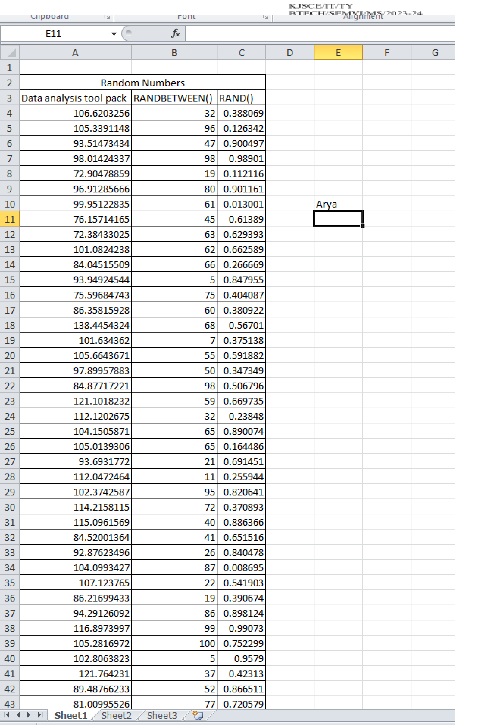

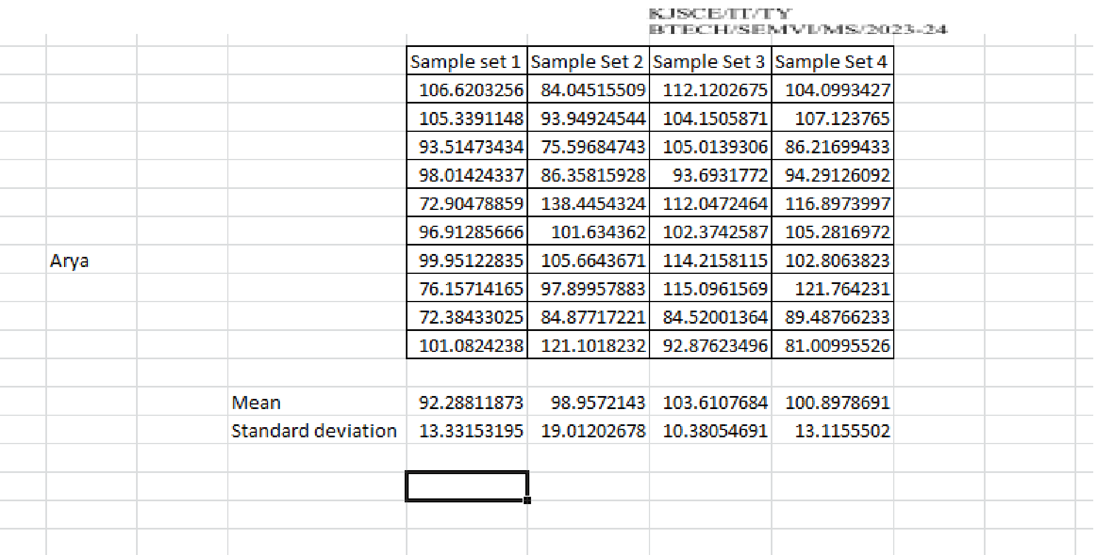

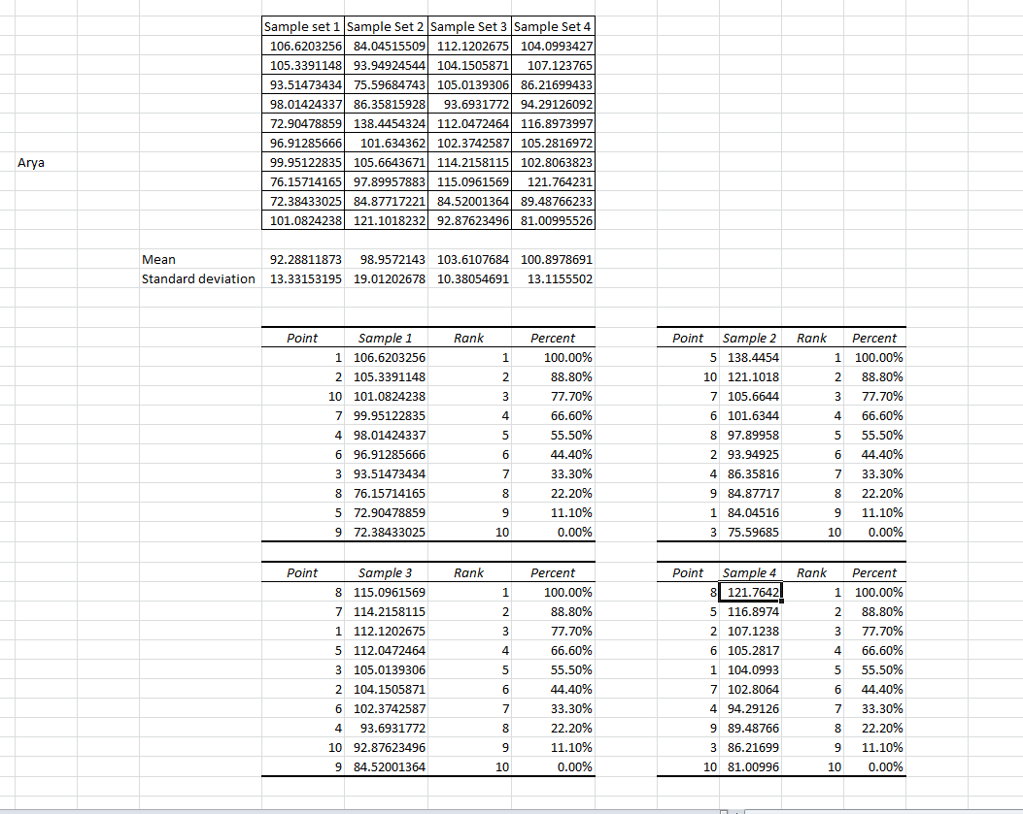

|  |  |
| --- | --- |
|  |  |

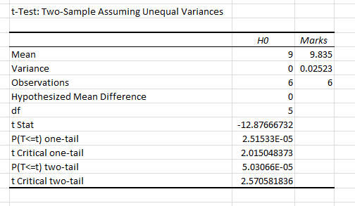

Compare the p valuewith the level of significance   
P = 0.000050306 and   
Level of significance = 0.05   
As P < LOS so H0 is accepted.

Therefore the assumed mean is consistent across 6 semesters.



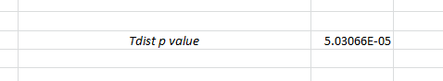



**H0 is accepted**

**Questions:**

1. Define the term sample and sampling with an example?

A sample refers to a subset of individuals or objects selected from a larger population, which is used to represent the entire population in a research study. Sampling is the process of selecting this subset from the population. For example, if a researcher wants to study the average height of students in a school, they might select a sample of 100 students from the entire student population.



2. Why is it necessary to do sampling during any research study?

Ans: Sampling is necessary during any research study for several reasons:   
Cost-effectiveness: It&#39;s often impractical or impossible to study an entire population due to constraints such as time, resources, and logistics.

Feasibility: Some populations are too large or dispersed to study comprehensively, making sampling the only practical option.

Accuracy: By carefully selecting a representative sample, researchers can make accurate inferences about the population as a whole.

Ethical considerations: Sampling allows researchers to minimize the burden on participants while still obtaining meaningful data.

3. What is the significance of p value?

Ans: The significance of the p-value lies in its role in hypothesis testing. In statistical hypothesis

testing, the p-value represents the probability of observing a test statistic as extreme as, or more

extreme than, the one observed in the sample data, under the assumption that the null hypothesis is

true. A small p-value (typically less than 0.05) suggests that the observed data is unlikely to have

occurred if the null hypothesis is true, leading to the rejection of the null hypothesis in favor of the

alternative hypothesis.

4. Joe is the third-string quarter back for the university of lower Alatoona. The probability that Joe gets into any game is 0.40.

(a)What is the probability that the first game Joe enters is the fourth game of the season? (b) What is the probability that Joe plays in no more than two of the first five games?

Ans: The probability that Joe enters the first game is (1 - probability that he doesn&#39;t enter in the   
first three games) * probability that he enters the fourth game. So, (Joe enters in the fourth game)=(1−0.40)3×0.40=(0.60)3×0.40=0.216×0.40=0.0864P(Joe enters in the fourth   
game)=(1−0.40)3×0.40=(0.60)3×0.40=0.216×0.40=0.0864.

Ans: To find the probability that Joe plays in no more than two of the first five games, we can calculate the probabilities of him playing in exactly 0, 1, or 2 games and sum them up.

Probability that Joe plays in 0 games: (1−0.40)5=0.07776(1−0.40)5=0.07776.

Probability that Joe plays in 1 game:   
(51)×(0.40)1×(1−0.40)4=0.2304(15)×(0.40)1×(1−0.40)4=0.2304.

Probability that Joe plays in 2 games:   
(52)×(0.40)2×(1−0.40)3=0.3456(25)×(0.40)2×(1−0.40)3=0.3456. Adding these probabilities together: 0.07776+0.2304+0.3456=0.653760.07776+0.2304+0.3456=0.65376.

**Outcomes: CO3 Analyze simulation results to reach an appropriate conclusion.**

**Conclusions: Thus we created random numbers using data analysis tool pack, randbetween() and rand() functions and compared the mean and standard deviation by taking 2 sample sets for each function. Also tested for hypothesis mean for pointer in last 6 semesters.**

**Grade: AA / AB / BB / BC / CC / CD /DD**

**Signature of faculty in-charge with dat**





**References:**

**Books/ Journals/ Websites:**

1. "[Linear Congruential Generators"](http://demonstrations.wolfram.com/LinearCongruentialGenerators/) by Joe Bolte[,](http://en.wikipedia.org/wiki/Wolfram_Demonstrations_Project) [Wolfram Demonstrations Project.](http://en.wikipedia.org/wiki/Wolfram_Demonstrations_Project)

2. Severance, Frank (2001). *System Modeling and Simulation*. John Wiley & Sons, Ltd. p. 86. [ISBN 0-471-49694-4.](http://en.wikipedia.org/wiki/International_Standard_Book_Number)

3. The GNU C library's *rand()* [in](http://en.wikipedia.org/wiki/Stdlib.h) [stdlib.h use](http://en.wikipedia.org/wiki/Stdlib.h)s a simple (single state) linear congruential generator only in case that the state is declared as 8 bytes. If the state is larger (an array), the generator becomes an additive feedback generator and the period increases. See the [simplified code t](http://www.mscs.dal.ca/~selinger/random/)hat reproduces the random sequence from this library.

4. ["A collection of selected pseudorandom number generators with linear structures,](http://citeseer.ist.psu.edu/viewdoc/download?doi=10.1.1.53.3686&rep=rep1&type=pdf)  [K.](http://support.microsoft.com/kb/231847) [Entacher, 1997". Retrieved 16 June 2012.](http://support.microsoft.com/kb/231847)

5. ["How Visual Basic Generates Pseudo-Random Numbers for the RND Function".](http://support.microsoft.com/kb/231847)

*Microsoft Support*. Microsoft. Retrieved 17 June 2011.

6. In spite of documentation on [MSDN](http://msdn.microsoft.com/en-us/library/bb432429%28VS.85%29.aspx), RtlUniform uses LCG, and not Lehmer's algorithm, implementations before [Windows Vista a](http://en.wikipedia.org/wiki/Windows_Vista)re flawed, because the result of multiplication is cut to 32 bits, before modulo is applied   
7. [GNU Scientific Library: Other random number generators](http://www.gnu.org/software/gsl/manual/html_node/Other-random-number-generators.html)   
8. [Novice Forth library](http://www.forth.org/novice.html)

9. Matsumoto, Makoto, and Takuji Nishimura (1998) ACM Transactions on Modeling and Computer Simulation   
10. S.K. Park and K.W. Miller (1988). ["Random Number Generators: Good Ones Are](http://portal.acm.org/citation.cfm?id=63042)

|  |  |  |  |  |  |  |  |  |
| --- | --- | --- | --- | --- | --- | --- | --- | --- |
| Hard | To | Find". | *Communications* | *of* | *the* | *ACM***31** | (10): | 1192–1201. |

[doi](http://en.wikipedia.org/wiki/Digital_object_identifier):[10.1145/63039.63042.](http://en.wikipedia.org/wiki/Digital_object_identifier)

11. [D. E. Knuth.](http://en.wikipedia.org/wiki/Donald_Knuth) *The Art of Computer Programming*, Volume 2: *Seminumerical*  *Algorithms*, Third Edition. Addison-Wesley, 1997. ISBN 0-201-89684-2.

Section 3.2.1: The Linear Congruential Method, pp. 10–26.

12. [P. L'Ecuy](http://citeseer.ist.psu.edu/132363.html)e[r (1999).](http://citeseer.ist.psu.edu/132363.html) ["Tables of Linear Congruential Generators of Different Sizes and](http://citeseer.ist.psu.edu/132363.html) [Good Lattice Structure".](http://citeseer.ist.psu.edu/132363.html)[*Mathematics of Computation***68**](http://citeseer.ist.psu.edu/132363.html) (225): 249–260. doi:[10.1090/S0025-5718-99-00996-5.](http://en.wikipedia.org/wiki/Digital_object_identifier)

13. Press, WH; Teukolsky, SA; Vetterling, WT; Flannery, BP (2007), ["Section 7.1.1.](http://apps.nrbook.com/empanel/index.html#pg%3D343)

[Some History",](http://apps.nrbook.com/empanel/index.html#pg%3D343) *Numerical Recipes: The Art of Scientific Computing* (3rd ed.), New York: Cambridge University Press[,](http://en.wikipedia.org/wiki/International_Standard_Book_Number) [ISBN 978-0-521-88068-8](http://en.wikipedia.org/wiki/International_Standard_Book_Number)   
14. Gentle, James E., (2003). *Random Number Generation and Monte Carlo Methods*, 2nd edition, Springe[r,](http://portal.acm.org/citation.cfm?id=59305&dl=ACM&coll=portal) [ISBN 0-387-00178-6.](http://portal.acm.org/citation.cfm?id=59305&dl=ACM&coll=portal)

15. Joan Boyar (1989). ["Inferring sequences produced by pseudo-random number generators".](http://portal.acm.org/citation.cfm?id=59305&dl=ACM&coll=portal)[*Journal of the ACM***36**](http://portal.acm.org/citation.cfm?id=59305&dl=ACM&coll=portal) (1): 129–141. doi:[10.1145/58562.59305.](http://en.wikipedia.org/wiki/Digital_object_identifier) (in this paper, efficient algorithms are given for inferring sequences produced by certain pseudo-random number generators).